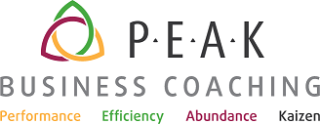

Year-End Business Evaluation Form

Master Coach Jim Kaspari (707) 246-3646
Jim@PEAKBusinessCoaching.com www.PEAKBusinessCoaching.com

Business/Life Goal or Project

Business or project description:

What did I want/expect? Goals?

What were the results?

What did I accomplish that I’m proud of? How will I celebrate?

What worked well?

What did not work well? What was my lesson and what did I learn?

Lessons learned:

What will I stop doing?

What will I continue to do or do more of?

What will I start doing?

